Algebra II 5th Six Weeks Exam Review (Chapters 8 and 9)
Show all work and answers on separate paper. This review is due on the day of your test; late reviews will NOT be accepted. The actual test will have 25 total questions (16 on the calculator section, 9 on the non-calculator section).

Chapter 9 Review Questions (Calculator-Allowed)

Is the relationship between the variables in the table a direct variation, an inverse variation, or neither? If it is a direct or inverse variation, write a function to model it. (pg. 497, example 2)

- 2.

x | –3 | –1 | 2 | 6
y |  |  |  | 5

x | –3 | 1 | 3 | 6
y

3. Suppose that y varies directly with x and inversely with z. y = 10 when x = 16, and z = 8. Write the equation that models the relationship. Then find y when x = 8 and z = 2. (pg. 498, examples 4 and 5)

4. Suppose that y varies directly with x and inversely with z. y = 15 when x = 10, and z = 4. Write the equation that models the relationship. Then find y when x = 2 and z = 2. (pg. 498, examples 4 and 5)

Simplify the rational expression. State any restrictions on the variable. (pg. 517, example 1)
5. 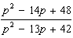 6. 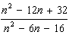 7. 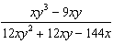

Multiply or divide. State any restrictions on the variables. (pg. 518-519, examples 3 and 4)
8. 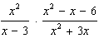 9. 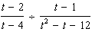 10. 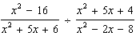

Add or subtract. Simplify if possible. (pg. 523-524, examples 3 and 4)
11. 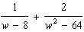 12. 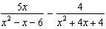 13. 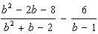

Simplify the complex fraction. (pg. 524, example 5)
14. 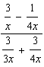 15. 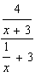

Solve the equation. Check the solution. (pg. 530-531, examples 1 and 2)
16. 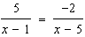 17. 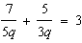 18. 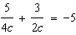

Chapter 8 Review Questions (Calculator-Allowed)

19. The half-life of a certain radioactive material is 84 hours. An initial amount of the material has a mass of 373 kg. Write an exponential function that models the decay of this material. Find how much radioactive material remains after 18 hours. Round your answer to the nearest thousandth. (see Pg. 448, example 3)

20. Suppose you invest $1600 at an annual interest rate of 4.6% compounded continuously. How much will you have in the account after 4 years? (hint: the formula for this is - make sure that you know this for the test!!!)

21. Write 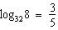 in exponential form. 22. Write 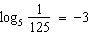 in exponential form. (see Pg. 455, example 2)

23. Solve . 24. Solve . (pg. 471, example 6)

Use natural logarithms to solve the equation. Round to the nearest thousandth. (pg. 480, example 4
25. 26.

NON-CALCULATOR SECTION!!!

Sketch the asymptotes and graph the function (use graph paper). (pg. 505, examples 4)
27. 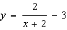 28. 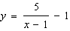

Find any points of discontinuity for the rational function. (pg. 510, example 1)

29. 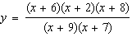 30. 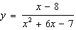

Describe the vertical asymptote(s) and hole(s) for the graph of each equation. (pg. 511, example 2)
31. 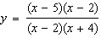 32. 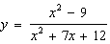

Find the horizontal asymptote of the graph of each equation. (pg. 512, example 3)

33. 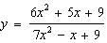 34. 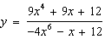 35. 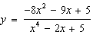

Graph the exponential function (use graph paper).

36.

Expand the logarithmic expression. (see Pg. 463, example 3)

37. 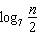 38.

Write the expression as a single natural logarithm. (see Pg. 478, example 1)

39. 40.
Algebra II 5th Six Weeks Exam Review (Chapters 8 and 9) - Solutions

1. inverse variation; 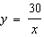

2. inverse variation; 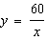

3. 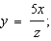 20 4. 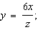 6

5. 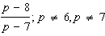

6. 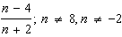

7. 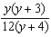

8. 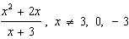

9. 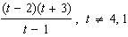

10. 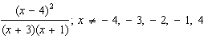

11. 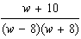 12. 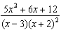

13. 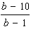 14.

15. 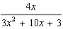 16.

17. 18.

19. 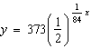; 321.516 kg

20. $1,923.23 21. 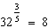

22. 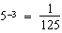 23.

24. 25. 0.293 26. –0.046
27.
28.

29. x = –9, x = –7 30. x = 1, x = –7

31. asymptote: x = –4 and hole: x = 2

32. asymptote: x = -4 and hole: x = -3

33. y = 34. y = 0 35. y = 0
36.

37. 38.

39. 40. 